Employee Benefit Management System
Sw Architecture Document

Table of Contents
Figure No. | Title | Page No.
1. | Architectural Representation | 3
2. | Architectural Decisions  2.a Low coupling/High Cohesion  2.b Creator and information expert  2.d Controller | 3  3  4  5
3. | Logical View  3.a Package  3.b Class Diagram | 6  6  7

List of Figures
Figure No. | Title | Page No.
1 | High coupling | 3
2 | Low coupling | 4
3 | Class diagram for creator decision | 4
4 | Sequence diagram for creator decision | 5
5 | Single point of contact between UI and Domain layer | 5
6 | Logical view of the Employee benefit system. | 6
7 | Interface between layers | 7

References:
- Design Model – Class Diagram.
- Design Model – Package Diagram
- Design Model – Sequence Diagram (Generate BI Reports)
- LoginUsecase.pdf – sequence diagram for employee

- Architectural Representation:

This document presents the architectural decisions based on GRASP patterns and later it explains the logical view which consist of package diagram and also class diagram which shows the interaction between layers.

- Architectural decisions:

  - Low Coupling/High cohesion:

Technical Memo: Issue: Control change of database systems.

Solution summary: Change of user interface may not affect the database system.

Factors:
- Database can be recovered within small amount of time and can maintain the stability by change of the user interface.

Solution:
The process of the system starts with displaying the menus and later choosing options give him the option to login which call the csv file to authenticate the user. This process follows the low coupling as no single class is dependent on other class. The Figure 1 shows the high coupling which led to dependent on menus and csvutility class [1, 4]. To avoid this we followed the larman’s process of low coupling and high cohesion.
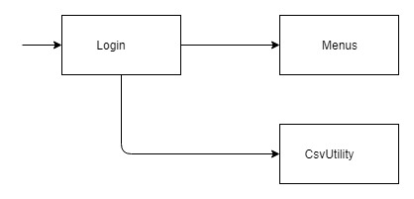
Figure 1: High coupling

The Figure 2 below shows the process which has been followed in the source code. The dependency is minimum which helps when there is change in any layer of the system.
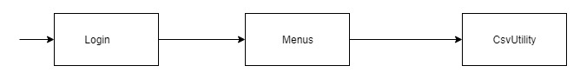
Figure 2: Low coupling

Motivation:
The motivation of this architectural decision is to avoid the concerns of the end user. This decision helps in making future changes to the system efficiently.

  - Creator and Information Expert:

Technical Issue: Initialization of business reports

Solution summary: The process of initialization of business reports is done only by the manager.

Factors: The business reports can be generated with authorization request and only by the expert of the system.

Solution:
This decision makes it easier for a manager to get any of the three reports which only can be initiated by only him. The Figure 3 below shows that class diagram which shows that BIReportingController can be only created by the manager which can be referenced from the Design Model [3]. Here, the manager is the expert who has knowledge of the system and also can get information from other class.

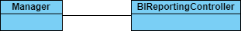
Figure 3: Class diagram for creator decision.

The Figure 4 shows the sequence diagram which was followed to express this technical memo.
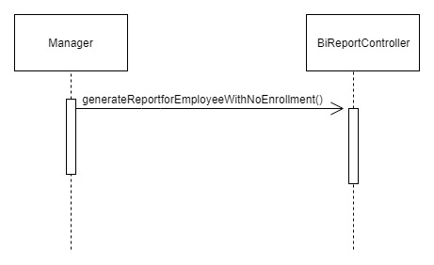
Figure 4: Sequence diagram for creator decision.

Motivation:
The motivation for this decision is to only give instantiation and information to the highest authority to get the files important to the organization.

  - Controller (Façade Controller)

Technical Memo: Issue: Controlling system by single point of contact

Solution summary: use of single package to control the actions.

Factors: Perform action by contacting the controller package in domain layer.

Solution:

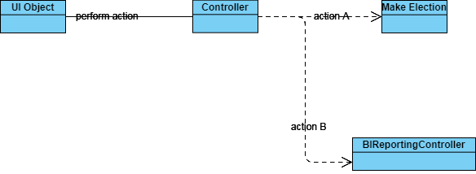
Figure 5: Single point of contact between UI and Domain layer.

The above diagram shows the process followed by the application to avoid the class interacting with many different classes to perform a certain action. The UI Object get a request from user which tries to contact with the domain layer which contains the package called the controller. The logical view of the architecture in next section explains the communication between different layers. Here the request is received from UI layers which tells the domain layer to perform action A or action B [2]. The action decides the class to be called.

Motivation:
The motivation of this issue is to make the controller to delegate task to other classes. Maintaining the state of use case is also possible. Can control the sequence of the activities.

- Logical View:
A logical view of architecture is the one which describes the most important classes, their organization in service packages [2] and subsystems, and the organization of these subsystems into layers. It consist of UI, Domain layer and Technical services

  - Package Diagram:
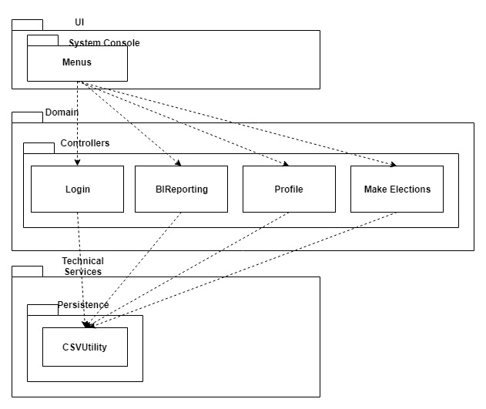
Figure 6: Logical view of the Employee benefit system.

Discussion:
The logical view of the Employee benefit system has 3 main packages:
- System Console: contains classes for each of the forms the actors use to communicate with the system. This package contains functionality which helps the user to send request and get responses from the system.
- Controllers: contains classes which performs operations based on the request which the users wants to execute. This package have four classes called Login, BIReportingController, Profile and MakeElections.
- Persistence: contain class called CsvUtility which performs request to the csv file to get data and display to the user based on the request made by the user. All the classes from the domain layers can request data from this package.

Motivation:
The system operation are simple so there is no interface between the UI and domain layer. The controller receives request from the UI layer which then assigns the class based on the action requested from the user. This system does not have logging feature in the technical services.

  - Class Diagram (Interface between domain and technical services) :

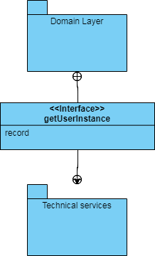
Figure 7: Interface between layers.

There is an interface between the Domain layer and Technical layer which is getUserInstance. This interface gets data from the persistence package and return back to the domain layer, which is eventually passed to the user interface. This interface gets data from the object called record which helps get the record from the csv file.

